`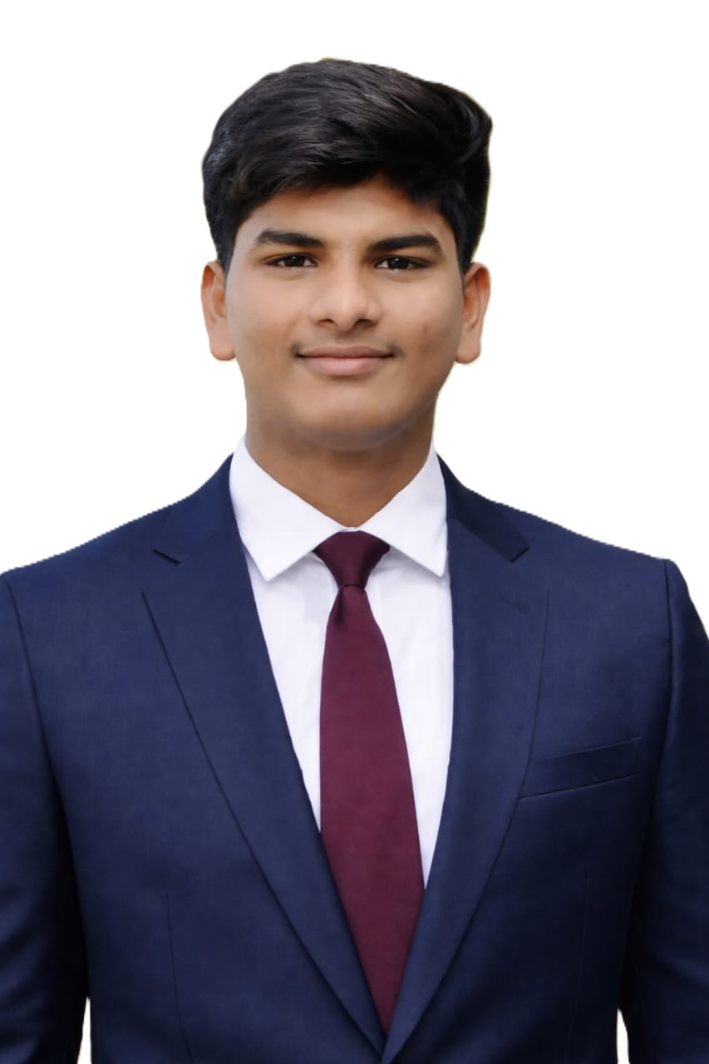Career Objective:

THALLA SRI PRADEEP

2-13, Chittaluru, Nellore,524341.

E. Mail: thllasripradeep@gmail.com|
Contact : +91 77993873327

Motivated AI & Data Science student with strong foundation in Python and data analysis, seeking an opportunity to apply analytical skills and contribute to organizational growth.
Educational Qualification:
COURSE | INSTITUTION | BOARD/  UNIVERSITY | YEAR OF COMPLETION | PERCENTAGE OF MARKS
B. Tech  [AI & DS] | Muthayammal  Engineering  College,  (Autonomous)  Rasipuram | Anna  University | 2027  (Pursuing) | 80.4
H.S.C | Viswasai Junior  College, Nellore | State  Board | 2023 | 97.3
S.S.LC | Lumbini Vidyalayam Em. High School  Nellore | State  Board | 2021 | 98.17

Technical Skills:
Languages: Python, SQL,.
Libraries: NumPy, Pandas ,.
Tools: Visual Studio Code.
Internship:
- Completed 3 Months Internship on “Software Developer” at Skilfull Technologies pvt ltd.

Mini Project:
Title: College Department Fund Management System.
Tools: Mern Stack, Python.
Description: The College Department Fund Management System is a web-based application developed to manage and monitor the financial activities of a college department efficiently. The system helps in recording, organizing, and tracking income and expenses digitally instead of maintaining manual records.
Certifications:
- I got Certified Elite + Silver in “Distributed Systems” with 80% on NPTEL .
- Earned the Salesforce Certified Agentforce Specialist certification, gaining knowledge in Salesforce.
Technical Activities:
Hackathon:
- Project presentation certificate in “Smart-India Hackathon” at Muthayammal Engineering College (Autonomous) Rasipuram.
- Project presentation certificate in “HackIndia 2025” at Muthayammal Engineering College(Autonomous) Rasipuram.
Paper Presentation:
- Presented paper on 5G IMPACT ON IOT on 15th September 2025 at Muthayammal Engineering College (Autonomous) Rasipuram.
Workshops:
- “Foundation course on Green Skills (based on Python)” in January 2026 at Muthayammal Engineering College (Autonomous) Rasipuram.
Personal Skills:
- Team Collaboration
- Effective Communication
- Time Management
- Problem Solving
Personal Details:
Father’s Name : Mr. T. Penchalaiah
Mother’s Name : Mrs. T. Srilatha
Date of Birth : 22.04.2006
Blood Group : O+
Languages Known : Telugu, English, Tamil,.
Declaration:
I hereby declare that the above mentioned statements are true to the best of my knowledge.
Place:
Date: (Thalla Sri Pradeep)

